**Steps to install Flex and bison in windows**

1. Install flex and bison, setups are given in google drive (setups folder).

2. Go to C:\Program Files (x86)\GnuWin32\bin and replace bison (application file) with the file given in modified_bison folder.

3. After successful installation go to C:\Program Files (x86)\Dev-Cpp\MinGW64\bin and copy the address of the bin. Then go to environment_variables->system variables->path->edit->new and paste the bin address here.

4. Then go to C:\Program Files (x86)\GnuWin32\bin and again copy the address of the bin. Then go to environment variables->system variables->path->edit->new and paste it here.

5. Make sure you keep the DevCpp/CodeBlocks path over the flex path as shown below:

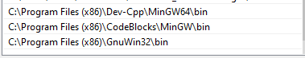

To check the installation, run the following commands in command prompt.

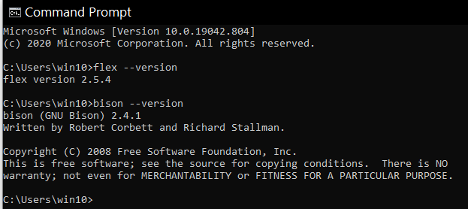

**Commands to compile and run the Lex and Yacc programs on windows**

1. Write your lex program in a text editor, save it with .l extension and save yacc program with .y extension.
2. Enter into the folder where you have saved your lex and yacc files using cd command and run following commands in command prompt:

**-> flex file_name.l (lex.yy.c file is generated after this command)**

**-> bison -dy file_name.y (y.tab.h and y.tab.c files are generated)**

**-> gcc lex.yy.c y.tab.c ( output file, a.exe is generated)**

**-> a.exe**

NOTE: Sample programs are given in sample programs folder

**Steps to install Flex and bison in Linux**

1. Open terminal and run the following commands

sudo apt install flex (for lex)

sudo apt install bison ( for yacc)

**Commands to compile and run the Lex and Yacc programs on Linux**

1. Write your lex program in a text editor, save it with .l extension and save yacc program with .y extension.

gedit file_name.l (lex program)

gedit file_name.y (yacc program)

1. Run following commands in terminal:

**-> lex file_name.l (lex.yy.c file is generated after this command)**

**-> yacc -d file_name.y (y.tab.h and y.tab.c files are generated)**

**-> cc lex.yy.c y.tab.c -ll ( output file, a.out is generated)**

**-> ./a.out**